Answers to these questions and teacher support can be found in the accompanying Guidance Notes.

Challenge 1: Understanding smart meters

Introduction – group discussion
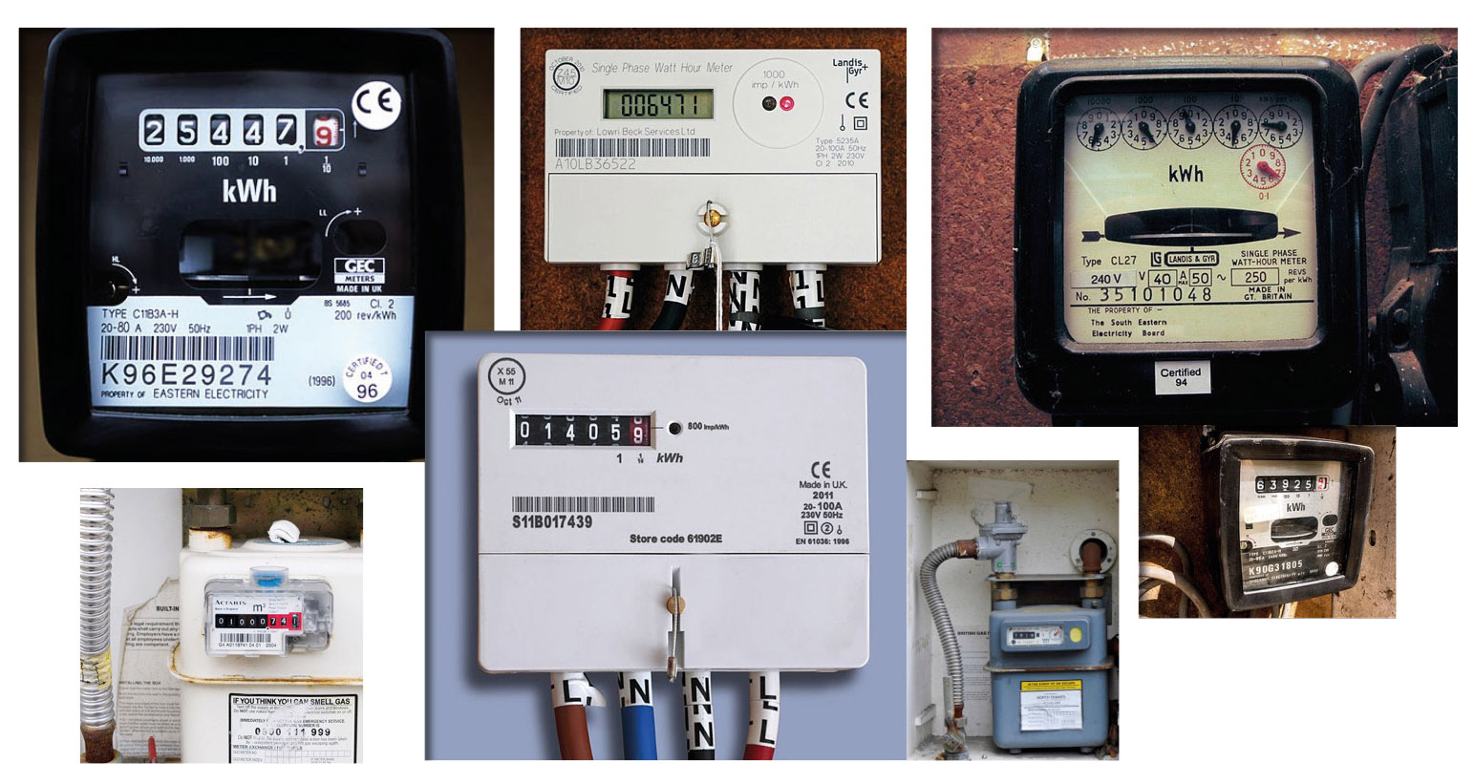

Fact finder
Write down in the box below a fact you’ve remembered from the film.

True or false?
Which TWO of these four sentences about smart meters are FALSE (circle the FALSE answers)?

- Smart meters were invented in 1792.
- Smart meters show you how much gas and electricity you’re using in real time and how much it costs.
- A trained installer will fit your new smart meter.
- You must have a smart meter installed by law.
Word spot
Which THREE words in this list are related to smart meters? (Circle the correct answers).

Outdoors
Electricity
Energy
Fireworks
Dog
Gas

What have I learnt?
Write a short sentence to describe what you have learnt about smart meters.

Challenge 2: The energy-saving benefits

A smart meter comes with an in-home display that shows you lots of useful information about your energy use, including:

- How much energy you’re using at that moment (this could include electricity and gas – or just one of them)
- How much it costs
- How much you’ve used in the past, so you can see when you’ve used lots of energy – and those days and times when you’ve used less
- You can even see how much it costs to use different electrical gadgets or if you turn the heating up or down. For instance: if you turn on a light, you should see the figure showing how much electricity you’re using now, increase on the screen.

When do we use the most electricity?

Look at the graph on the next page∗. Can you work out the two times of the day when we use the most electricity? (Clue: look for the two biggest ‘humps’). Draw the start time for these two busy periods on the blank clock faces below the graph.

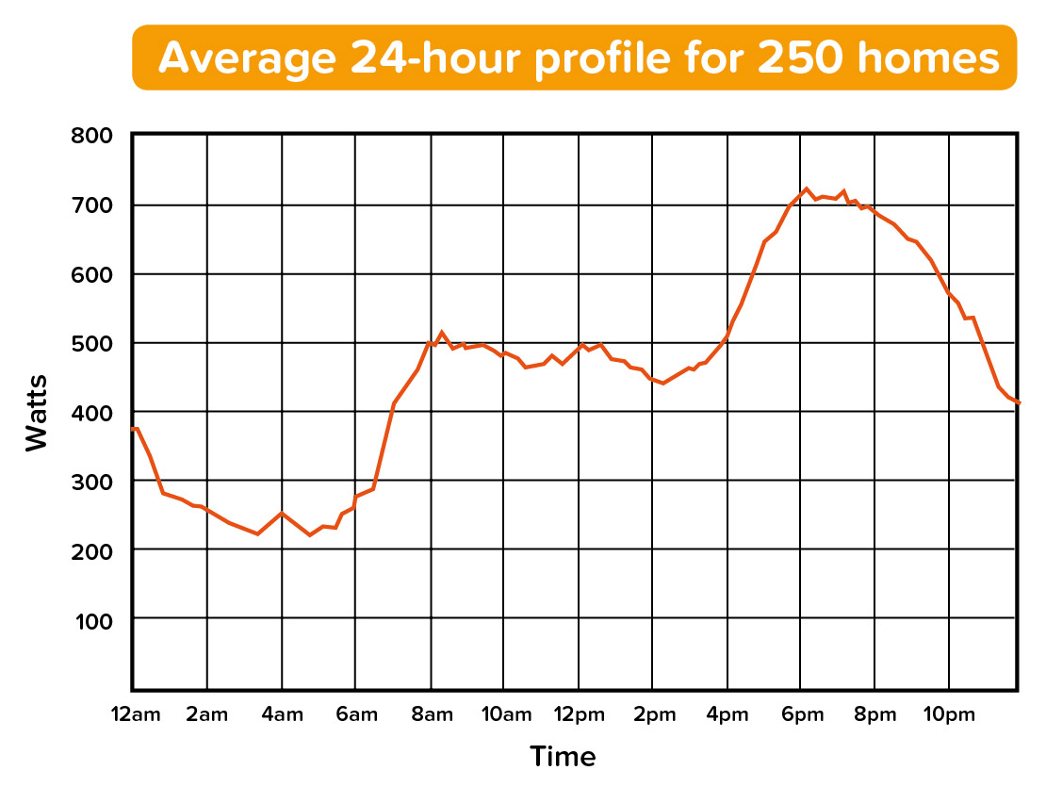
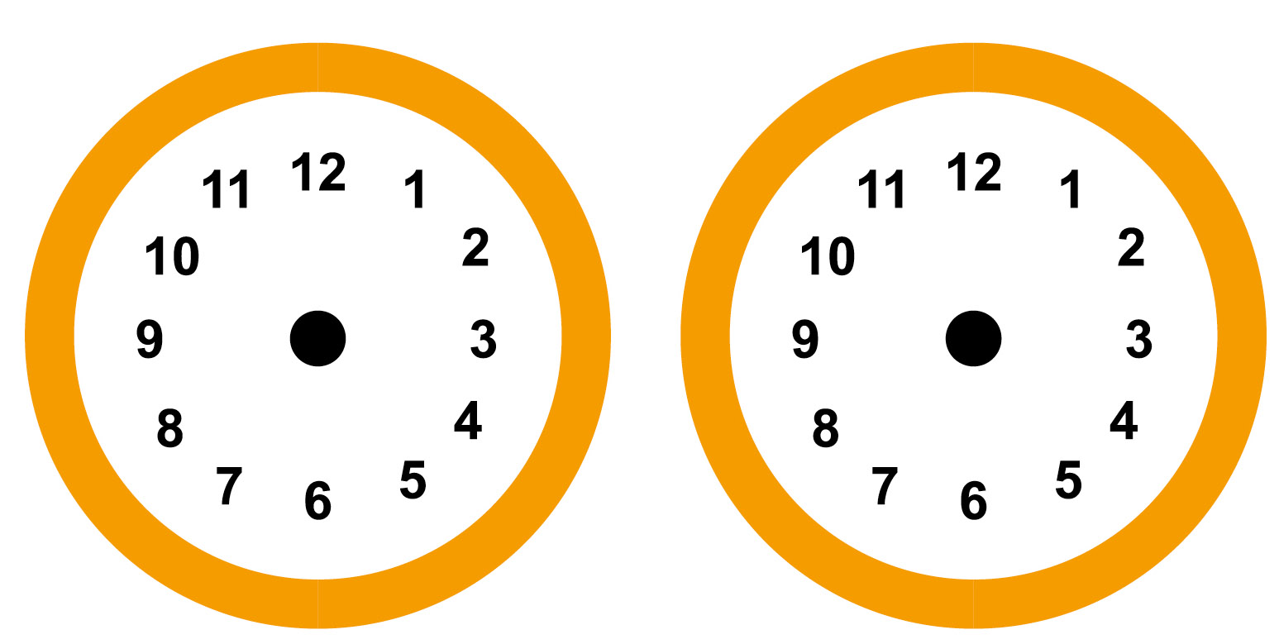

Optional question. What are you usually doing at these times at home? Why do you think we use so much electricity at these times? Write your answer in the box below.

Turn to the next page for more maths questions…
Working out your electricity use
Look at the three in-home displays below. The in-home display shows you how much electricity you’re using*. There is a light on the top of the in-home display that shows whether you’re using a high (red), medium (amber) or low (green) amount of energy. The kW number at the top of the screen shows you exactly how much electricity you’re using at that moment in time, and this is also shown by the coloured dial (green (low), amber (medium) and red (high)). The bottom half of the screen shows you how much your electricity costs.

For each display below, write in the box beneath it how much electricity each home is using at the moment. (Clue: look for the kW number).
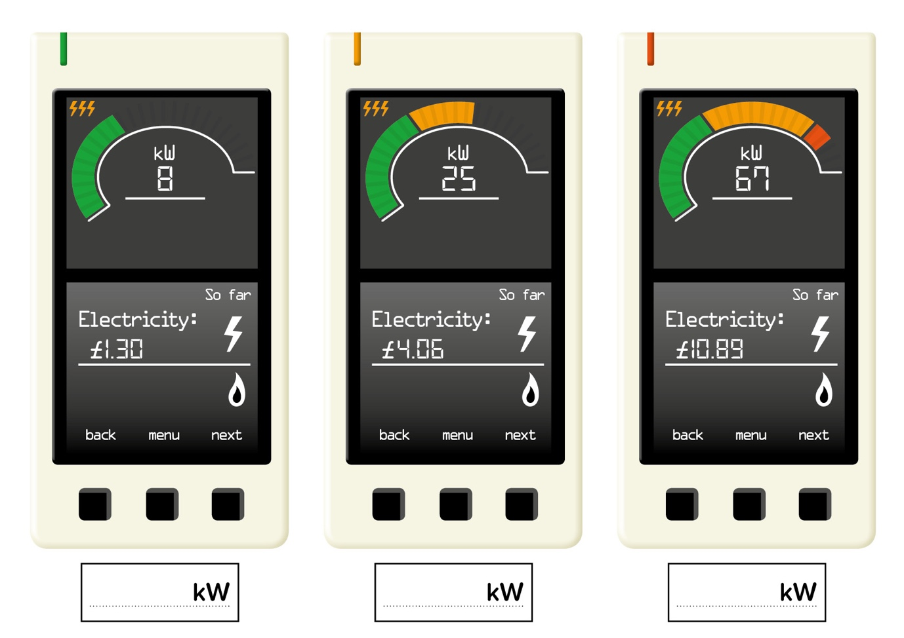
Turn to the next page for more maths questions…
The cost of gas
As well as showing you how much electricity you’re using, the in-home display shows how much gas you’re using too. Gas is indicated by a blue coloured dial (instead of the green/amber/red dial for electricity use), and the larger the dial, the more gas is being used. The kW number at the top of the screen tells you exactly how much gas you’re using at that moment in time, while the bottom half of the screen shows you how much your gas costs.
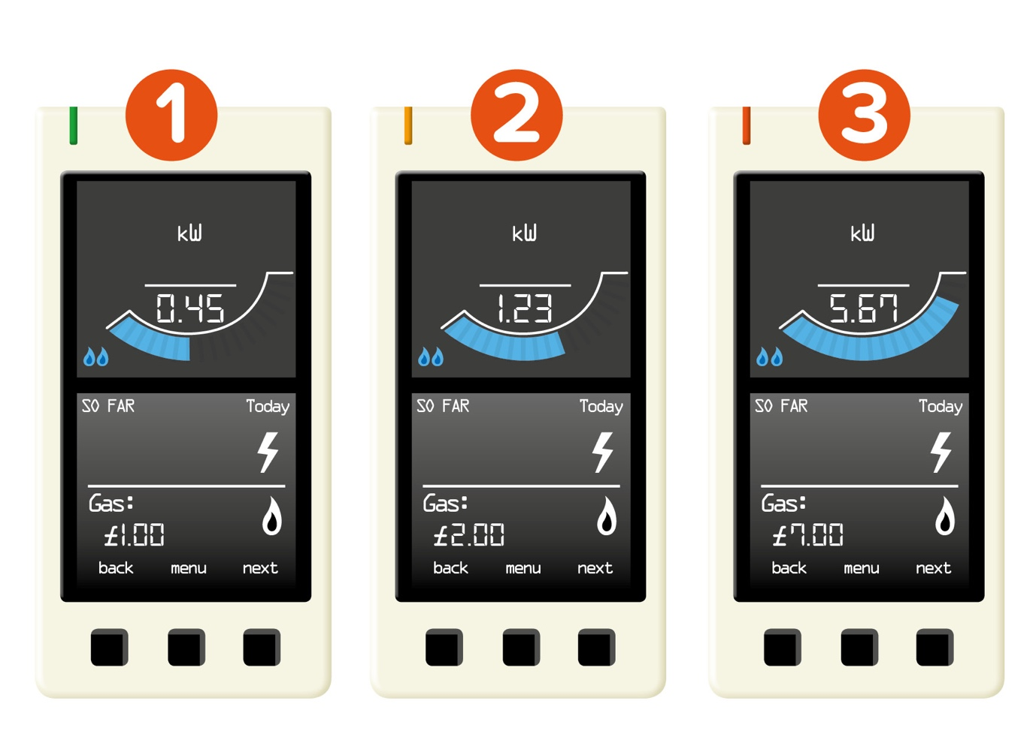

Q1. Look at in-home display number 1 for the Lee family. How much has their gas cost so far today? (Clue: it’s the number with the £ at the bottom of the screen).

Q2. If the Lee family (in-home display number 1) spent £1 on gas every day, how much would their week’s gas cost? (Clue: a week is 7 days).

Q3. Compare in-home displays 1 (for the Lee family) and 2 (for the Khan family). Which family has paid the most for their gas so far today? (Clue: which shows the biggest £ number?)

Q4. What’s the difference in cost between in-home display 1 and in-home display 2?

Q5. Can you show the cost on in-home display 1 as a fraction of the cost on in-home display 2? (Clue: a fraction is written like ¼ or ½)

Q6. Look at in-home display 3 for the Ahmed family. It’s nearly the end of a busy day – and they've used a lot of gas today to heat hot baths, cook food and warm the house. In the box below, write down how much their gas has cost so far today (Clue: it’s the number at the bottom of the screen).

Q7. If the extra gas they use before bed costs £2, how much will their gas have cost in total by the end of the day? (Clue: Add £2 to your answer for Q6.)

How much electricity do we use in a day?

Q8. Look at the table below showing how much electricity a home has used over a day. Can you work out the total amount of electricity used and write it in the space below? (Clue: add up all the numbers.)

Time | Midnight–6am | 6am–12pm | 12pm–6pm | 6pm–Midnight
Electricity used (kWh) | 0 | 2 | 6 | 4
Total:

Q9. Can you use the numbers in the table above and colour in the grids below to create a bar graph that shows how much electricity this home has used over the day?
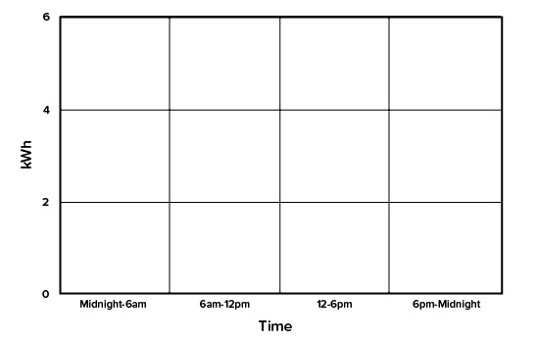

How much electricity do we use in a year?

This graph shows the amount of electricity a home might use over a full year. It’s already been filled in, but can you label each of the bars correctly as Low / Medium / High based on the amount of electricity they’ve used? (Write the words in the space beneath the bottom of each bar).

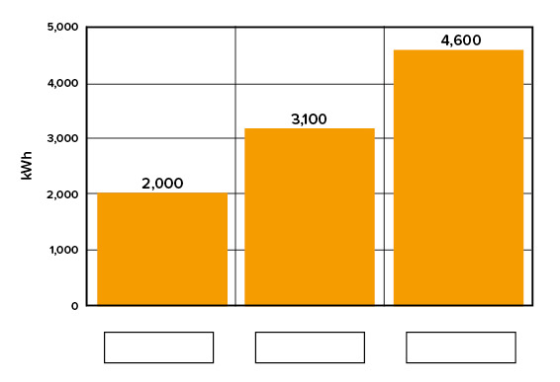

Challenge 3: Changing behaviour

The top of the in-home display has a light that turns red (high), amber (medium) or green (low) to show how much electricity or gas we’re using right now. We can use this to identify when we’re using more electricity and gas than usual – the light will be glowing red – and think about what actions we can take to use less energy during these times.

What uses energy?
Look at the pictures below. CIRCLE those that you think use electricity or gas and CROSS OUT those that don’t use electricity or gas.

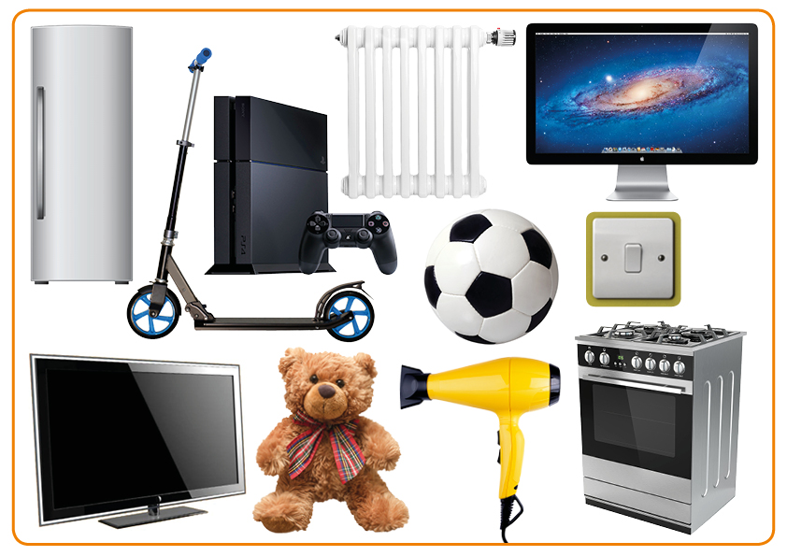

Saving energy

Write down ONE thing you’re going to do to use less electricity or gas.

Write down ONE thing your family could do to use less electricity or gas.

Write down ONE thing children (and teachers!) at school could do to use less electricity or gas.

Take action
Now you’ve learnt some ways in which you could save energy, why not share it with others by creating a poster? The most eye-catching posters tend to be those that focus on one message. So why not pick one fact or energy-saving idea and focus on this as your main message? Include a picture on your poster and don’t forget to use colour / words / size to make your poster really stand out.

Extension activity: Smart meter facts

My favourite smart meter fact is…

If you enjoyed this, why not download our
quick activity and go on an Energy Adventure?
(www.jointhepod.org/energyadventure)

∗ Source: https://www.gov.uk/government/uploads/system/uploads/attachment_data/file/275484/electricity_survey_2_tuning_in_to_energy_saving.pdf (page 2)
* The pictures show one type of in-home display; other models are available

