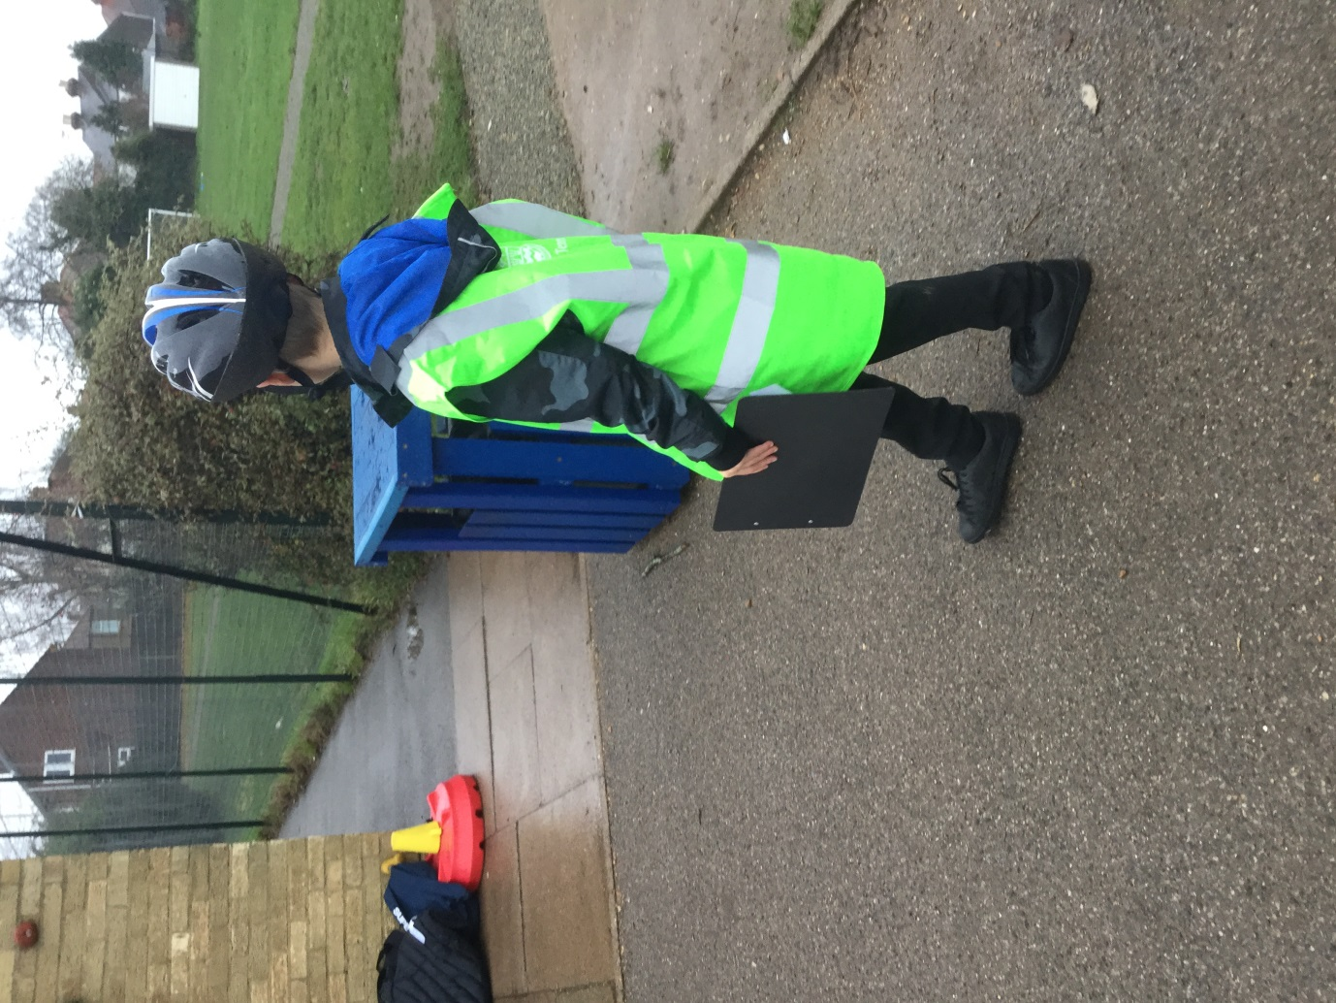
Chennestone School took part in Road Safety Week 2018. The Green team completed an audit to see who wore helmets to school when riding a bike or scooter. Out of 83 children only 41 wore helmets. We needed to take action! The children spoke to the whole school in an assembly and reminded them of how to keep safe on bikes and scooters. Year 1 and 2 took part in pedals training. The whole school designed helmets and posters in a whole school competition. We then spent a morning greeting children as they came into school and auditing how many of them wore helmets. We published the results in the news letter and encouraged the parents to support wearing helmets and for everyone to be 'Bikesmart'.

